
VISHNU INSTITUTE OF TECHNOLOGY
Department of Computer Science and Engineering

Food Waste Management App
Project Report
Student Name | N Sudhakar
Registration Number | 24PA1A05G5
Department | Computer Science and Engineering
Project Title | Food Waste Management App
Platform | Flutter and Dart
Submitted by
N Sudhakar
Registration Number 24PA1A05G5

Project Description
The Food Waste Management App is a Flutter mobile application designed to support responsible consumption and production. It helps users record food items, monitor expiry dates, use ingredients before they spoil, and donate surplus food to nearby community partners. The application addresses food waste at the household level through simple daily actions and clear visual reminders.

Objectives
- Help users maintain a digital pantry with food category and expiry information.
- Highlight food items that should be consumed soon to reduce avoidable waste.
- Encourage reuse through recipe suggestions based on available items.
- Support food sharing by presenting nearby donation partners.
- Promote sustainable habits through an easy and motivating interface.

Core Features
Feature | Purpose
Home dashboard | Shows meals saved, money saved, carbon impact, and items that need attention.
Pantry management | Stores food items with category labels and the number of days left.
Add food form | Allows users to add an item, choose a category, and set a use-by period.
Donation partners | Lists nearby community fridges and foundations for surplus food donation.
Profile settings | Provides expiry reminder, monthly goal, and help options.

System Architecture
The app follows a simple layered Flutter architecture. The presentation layer contains responsive Material Design screens. Stateful widgets manage user interactions and pantry data. The current prototype uses in-memory data, while the data layer can later be extended with a local database, notifications, and external donation services.
Presentation Layer | Application Layer | Data and Service Layer
Flutter Material UI  Home, Pantry, Donate, Profile  Navigation bar and forms | Stateful widgets  Pantry item management  Expiry prioritisation  Donation workflow | In-memory food list  Future local database  Notification service  Donation partner API

Application Flow
- The user opens the Home screen and sees impact metrics and food items that require attention.
- The Pantry screen displays all tracked items and their remaining days before expiry.
- The Add Food action saves a new item with its selected category and usage period.
- The Donate screen helps users start a donation request with a nearby partner.
- The Profile screen centralises reminders, goals, and food-waste guidance.

Project Structure
food_waste_management/
|-- lib/
| `-- main.dart # UI, navigation, and app logic
|-- pubspec.yaml # Flutter project configuration
`-- analysis_options.yaml # Lint configuration
The prototype keeps the user interface and basic state management in main.dart. As the app grows, it can be separated into models, screens, reusable widgets, services, and local storage modules.

Code Snippets

App Entry and Material Theme
void main() => runApp(const SavoraApp());
class SavoraApp extends StatelessWidget {
@override
Widget build(BuildContext context) {
return MaterialApp(
title: 'Savora',
theme: ThemeData(useMaterial3: true),
home: const MainScreen(),
);
}
}

Food Item Model
class FoodItem {
FoodItem({
required this.name,
required this.category,
required this.daysLeft,
required this.icon,
});
final String name;
final String category;
final int daysLeft;
final IconData icon;
}

Expiry Priority Logic
final urgent = pantry
.where((item) => item.daysLeft <= 2)
.toList();
final isUrgent = item.daysLeft <= 2;
final label = item.daysLeft == 0
? 'Use today'
: '${item.daysLeft} days left';

Add Food Interaction
void _addFood() async {
final FoodItem? item = await showModalBottomSheet<FoodItem>(
context: context,
builder: (_) => const AddFoodSheet(),
);
if (item != null) setState(() => _pantry.add(item));
}

Application Outputs
The following screenshots demonstrate the implemented user interface. The app uses an eco-friendly green palette, rounded cards, and a bottom navigation bar to make food management quick and approachable.
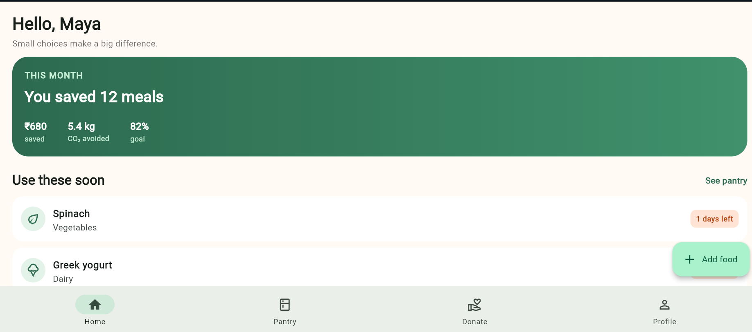
Figure 1 Home screen
The Home screen summarises monthly food-saving impact, highlights items that should be used soon, and offers quick actions.

Application Outputs
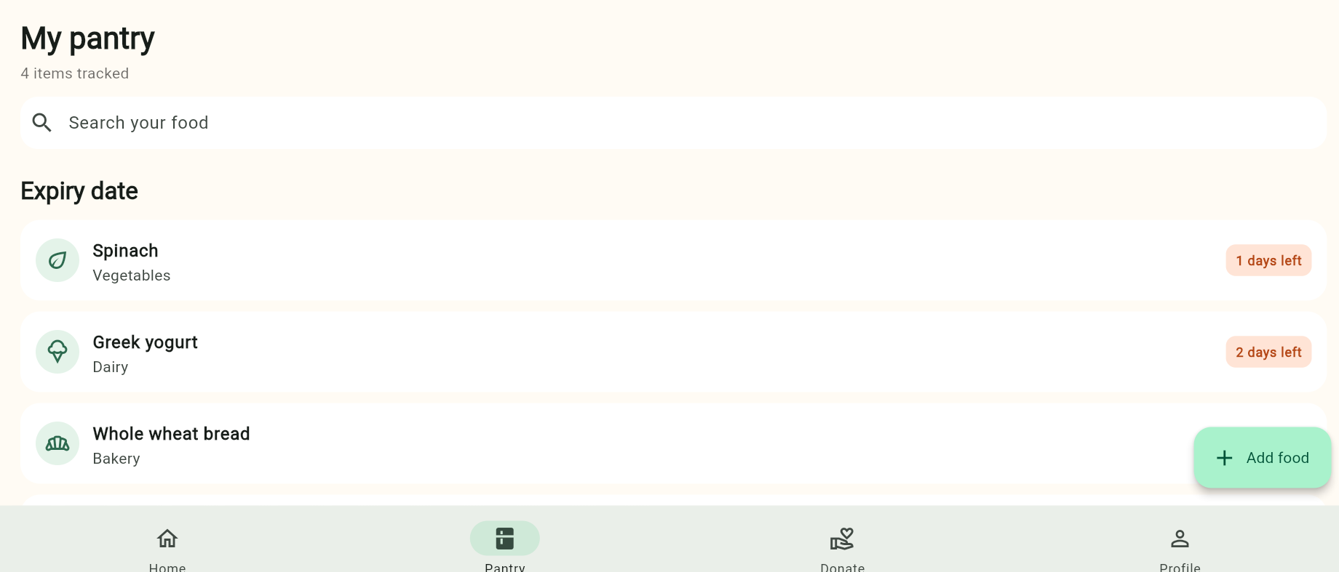
Figure 2 Pantry screen
The Pantry screen displays the tracked food inventory, search input, category details, and expiry status labels.

Application Outputs
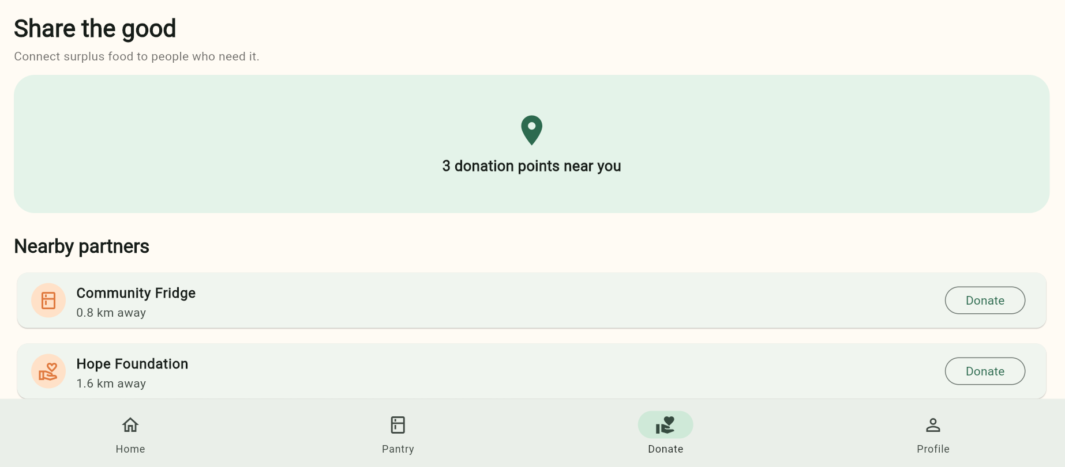
Figure 3 Donation screen
The Donation screen shows nearby food-sharing partners and provides a direct Donate action for each partner.

Application Outputs
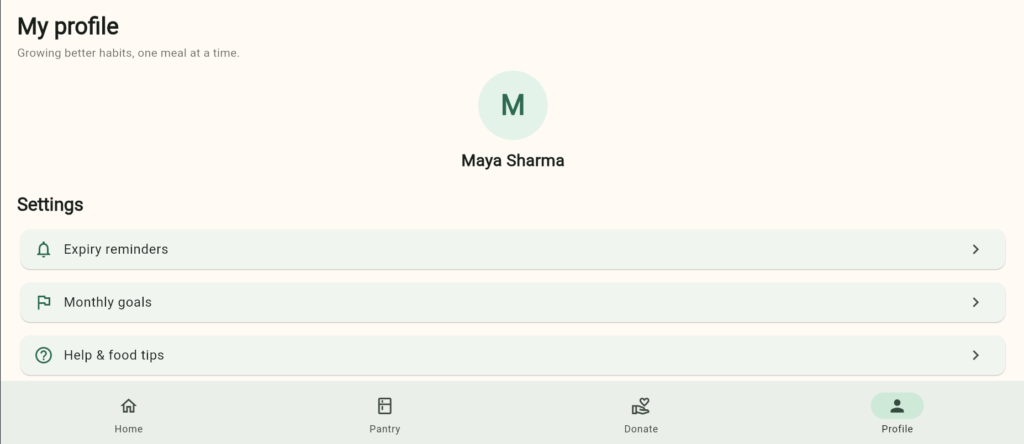
Figure 4 Profile screen
The Profile screen provides a focused settings area for expiry reminders, goals, and food-waste help.

Conclusion
The Food Waste Management App provides a practical digital solution for reducing household food waste. Its pantry tracking, expiry awareness, recipe direction, and donation support encourage users to make sustainable choices before food is discarded. The Flutter implementation provides a clean base for future additions such as database storage, push notifications, barcode scanning, real-time maps, and authenticated user profiles.

Future Enhancements
- Local database storage using Hive or SQLite for persistent pantry data.
- Scheduled notifications before a food item reaches its expiry date.
- Barcode scanning to add packaged food quickly.
- Location-based maps for verified community fridges and food banks.
- Recipe recommendations based on user preferences and pantry ingredients.

